Price elasticity of demand is the responsiveness of quantity demanded for a change in price.
Taiwan rail corporation increased its prices by 2.6% in October 2017. The are expecting a rise in revenues caused by the increase in price.
The PED for the rail service is likely to be inelastic. This is because the revenues are likely to increase after the rise in price. This shows that consumers would reduce the use of the service by a very small quantity in comparison to the increase in price and therefore, the total revenue may rise leading to higher profits for the organization.

Monopolies are market structures in which one firm dominates the market. The revenues generated by monopoly firms are the revenues for the industry and are price makers. Perfectly competitive markets are where there are many buyers and sellers with homogenous products trying to sell to the same customers. They are price takers.
As per the case, the government regulators in Taiwan has criticized the railway corporation for exploiting the consumers by charging higher prices for their tickets. However, a spokesperson from the company has defended the firm by claiming that they are being efficient and are trying to charge lower prices than it would have been if they were operating in a competitive market.
The rail transport corporation is the only transport provider in the country as it has replaced other means of transport such as airlines and buses. Therefore, they may receive many consumers who may purchase ticket to travel from one destination to another in Taiwan. This would result in them experiencing lower costs as they are able utilize their maximum capacity in their trains. This provide them with the opportunity to be productively efficient and thus, charge lower prices to consumers. In contrast, competitive market firms are price takers and may have to charge the price that is fixed by the market forces. For instance, if there is a flock of demand and limited supply in the market, the prices may rise to a certain level and therefore, the price charged by the monopoly would be much less comparative to the competitive market prices. As a consequence, consumers may experience higher consumer surplus and therefore, more disposable income and thus, improved living standards.
Furthermore, as the rail transport corporation is making higher profits which is evident through the graph below, they are likely to charge lower prices which may be even lower than the competitive market prices.

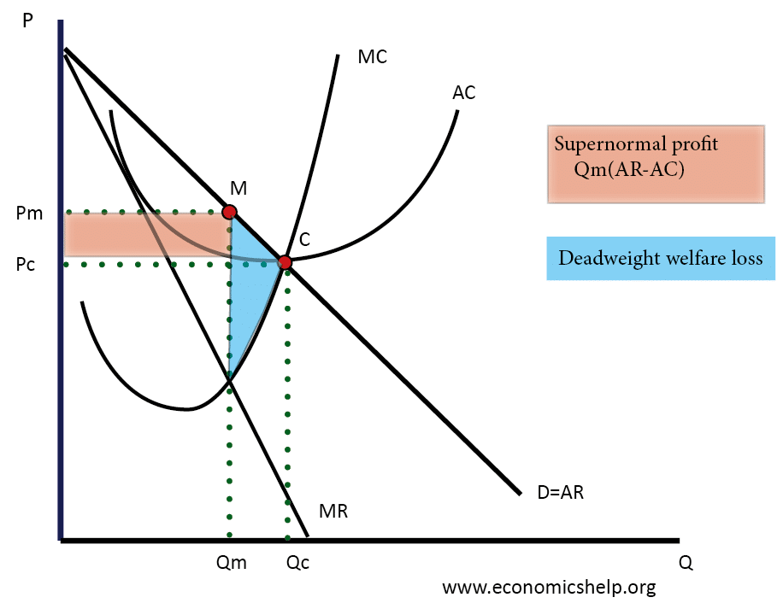

However, the rail transport corporation may be inefficient as there is a lack of competition. This reduces the incentive to be cost minimizer as they may charge higher prices to the consumers and cover the wastage costs. And thus, this could lead to X – inefficiency and eventually leading to even higher prices than the competitive market prices.
Moreover, in the short-run rail transport corporation is likely to charge higher prices but in the long-run they may charge lower prices. This is because in the short-run they may want to maximize profits while in the long-run they may fear the entry of new transport firms into the market and thus, to erect barriers to entry and maintain their market share lower prices may be charged.
Conclusively, Rail transport corporation is dynamically efficient and therefore, they may invent new systems or purchase electric trains that may not require drivers. Therefore, they can get rid of the labour costs which means they may charge lower prices for their tickets.

Monopsonist is a sole buyer of a particular good or service. They are able to exploit their suppliers by negotiating for lower prices. Eg: NHS is the sole buyer of nurses in the UK.
As per the extract 2, the Vietnam electricity buyer, EPTC, was claimed to break the law as it purchases electricity only from companies that are in the Vietnam electricity group. As per the extract 3, Morrison’s has charged 67 of its suppliers for displaying their names on Morrison’s websites without their permission. Further, Tesco was also fined for charging suppliers to place their products at the best position in their shelves.
One of the main benefits for a supplier of supplying their products to Tesco is that they are able to earn a massive amount of revenues. This is because, Tesco is one of largest supermarkets in the UK and many consumers purchase their daily products from this supermarket. Hence, they would purchase products in bulks from their supplier which means the revenues and profits for the supplier may be higher.
However, the monopsonist may negotiate for very low prices as they have the buying power to do so. The supplier may have to reluctantly agree for the lower prices as if they do not, they may lose the customer. This will result in no or little revenues being made and thus, the business would cease to exist. Therefore, employees in the business may experience a fall in their wages or salaries and eventually result in lower standards of living.
Moreover, monopsonist such as Morrison’s may also dictate terms and conditions such as Quality that has to be maintained by the suppliers. This may be costly as suppliers may be a small organization. Hence, they may earn losses due to the high costs exceed the revenues made. The suppliers can seek for customers from overseas who may be willing to pay higher prices for the supplies, therefore, this may increase their profit margins.
Conclusively, the government could intervene in the market and set price floors (Minimum prices) which may protect suppliers from being exploited from these large monopsonists and thus, grow their business.

